[Shashank Mondrati](mailto:smondrat@uncc.edu)

1. A 64-bit word computer system employs an 8 MB cache. The address bus in this system is 38 bits. Determine the number of bits in each field of the address to be seen in the cache using:

**Word Size: 8 Bytes, No of bits to represent = 3bits**

**No of words in cache = 8MB/8B = 2^20**

* 1. Fully associative mapping with a line size of 16 words

**Line = 16 words  
No of bits to represent line = 4 so [2^4=16]  
Main memory has 38 words and has word addressable**

**No of bits in tag = Total bits - Bits line= 38 - 4 = 34  
So that would be Tag equals 34, line equals 4 bits**

* 1. Direct mapping with a line size of 32 words  
     **Line size = 32   
     No of bits to represent =5 [ 2^5=32]  
     No of lines in cache = No of words in cache /No of words in line = 220 / 32 = 215   
      No of bits to represent lines = 15  
     Main memory has 38 words and has word addressable  
     No of bits in tag = Total bits - Block offset bits - Line bits = 38 - 5-15 = 18  
     So tag would be 18bits, Line = 15bits, and Blockoffset = 5bits**

1. A 32-bit word computer system has a main memory of 2 GB, and has a 16 MB 8-way set associative cache with a line size of 32 words. How many bits is each field of the address (Tag, Index, Word, Byte)?  
   **No of bits in block offset i.e. word = 7 bit  
    No of sets that is index field = 16 bit   
   so tag field is = Main memory size bit - block offset - set number  
    => 31 - 16 - 7 = 8 bit   
   Now Byte which has nothing but tag directory size = Number of lines in cache times Number of bits in tag = 16 * 8 = 128 bit = 16byte**
2. A computer system has a main memory which is cached with a Direct Mapped cache. The memory addresses of the system have a 14-bit Tag field, an 11-bit Index field, a 4-bit word field, and a 3-bit byte field. What is the size of the main memory in bytes? What is the size of the cache in bytes? How many words are there per cache line? How many bits are the world in the system?  
   **Tag field = 14bits  
   index = 11bits  
   word = 4bits  
   byte = 3 bits field  
   Main memory size = 2^(address size) = 2^29 words = 2^29 * 2^3 = 2^32 which is 4GB  
   Cache size = 2^(index + offset) = 256Kb  
   Words in cache line = 16words  
   bits/word = 64bits**
3. According to theory, which cache organization (Direct Mapped, Set Associative, or Fully Associative) tends to have the highest average hit to miss ratio, and why? Which tends to have the lowest hit to miss ratio, and why?  
   **Line Size = 64 bytes = 2^6 bytes  
    Number of bits in word = 6 bits   
   Total number of lines in cache = Cache Size/Block Size   
   = 8 MB/64 bytes = 2^23 bytes/ 2^6bytes = 2^17bytes   
   Number of words of index = 17 bits   
   Main Memory Size = 512 MB = 229 bytes.  
    Number of bits in physical address = 29   
   Number of bits in Tag = Number of bits in the physical address - (Number of bits in index + number of bits in word) = 29 - (17+6) = 29-23 = 6 bits  
    Total bytes of memory in caches = 264 bytes.**
4. Design the memory organization of a computer system with 32 - bit address bus and 32 - bit data bus using 512 Mbyte*8 - bit memory blocks. What is the minimum size memory in byte that the system can have?

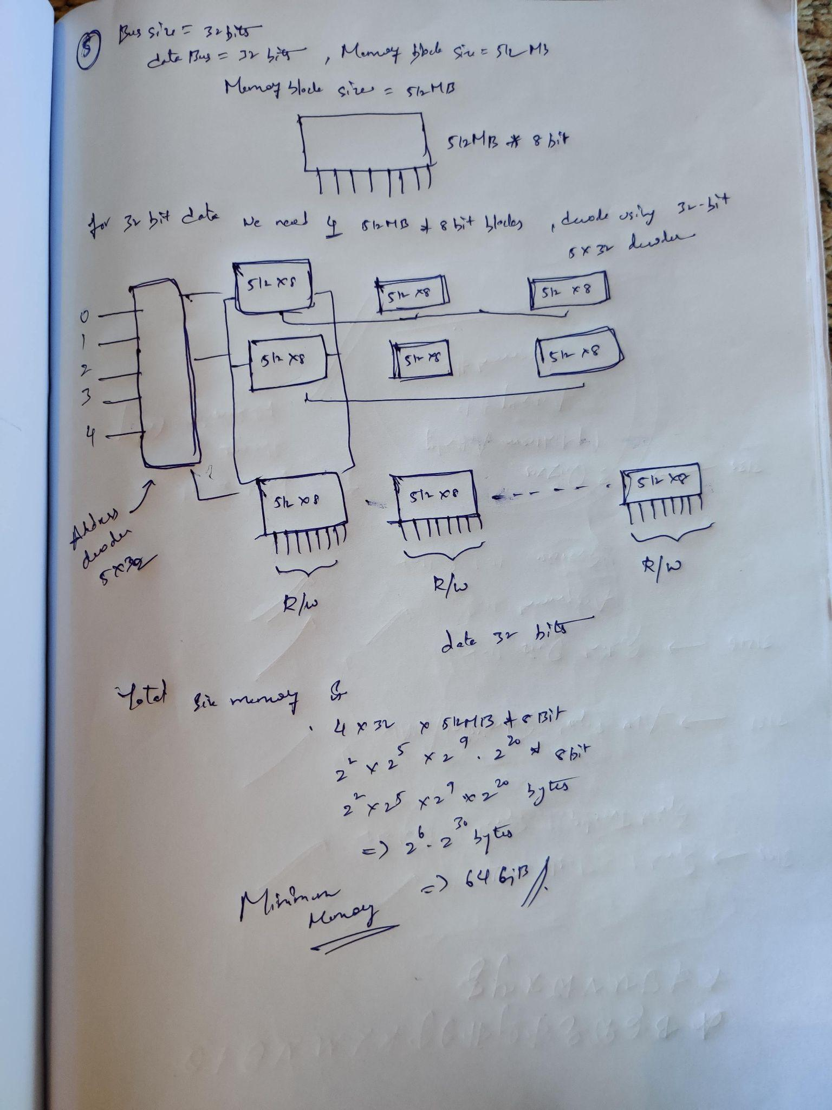

1. A computer system has a five-stage pipeline consisting of IF, ID, OF, EX, and ST. Assuming only IF, OF, and ST will access the main memory. Assume all instructions use every stage of the pipeline, **except 2 and 5 do not use ST**. Show the schedule for 6 instructions. There are no dependencies between any of these instructions. Assume two-way interleaving. **An instruction will spend 1 cycle in any stage it must use.**

| **ST** |  |  |  |  | **1** |  | **3** | **4** |  | **5** | **6** |  |  |
| --- | --- | --- | --- | --- | --- | --- | --- | --- | --- | --- | --- | --- | --- |
| **EX** |  |  |  | **1** | **2** | **3** | **4** |  | **5** | **6** |  |  |  |
| **OF** |  |  | **1** | **2** | **3** | **4** |  | **5** | **6** |  |  |  |  |
| **ID** |  | **1** | **2** | **3** | **4** |  | **5** | **6** |  |  |  |  |  |
| **IF** | **1** | **2** | **3** | **4** |  | **5** | **6** |  |  |  |  |  |  |